Maroochy Waterwatch Inc – River Patrol Report for June, 2017.

Number of Report Sheets : 12 completed......same as last month..
Total volunteer hours : 118 man hours. A little less than last month, nevertheless great.
Total non-recyclable bags collected : 10.5 bags – approx 525 litres compared to 13.25 bags – approx 662.5 litres previous month. Slightly less than previous month.....however still a great effort..
Total recycled bags collected : 5 bags, approx 250 litres, compared to 6.25 bags, approx 312.5 litres previous month. Similarly, a little less than last month.

Rubbish reported collected :
One of each unless stated otherwise :
- Milk crate
- Timber plank
- Bucket
- Timber plank.
- Cushion
- Oil drum
- Broken fishing rod.
- 2 x camp chairs
- Shade cloth tent.
- Misc. thongs.
- Large sheet of clear plastic
- Pieces of rope
- Pieces of cardboard
- Lots of confectionary wrapping
- Rectangular wooden bench in new condition, so replaced on river bank – Petrie Creek
- Car tyre
- Plastic water container
- Drainage pipe.
- Plastic pieces & containers of all sizes & shapes.
- Glass & plastic bottles of various sizes.

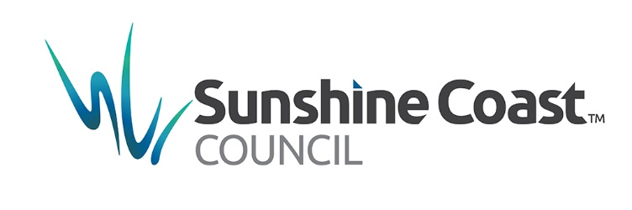
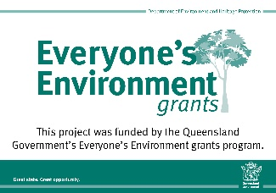
The last two items show repeatedly in most report sheets & generally without indicating quantities, simply because there are so many of these items retrieved from the banks; mangroves or floating.

