Maroochy Waterwatch Inc – River Patrol Report for August 2016.

Number of Report Sheets : 10 compared to 8 the previous month.

Total volunteer hours : 92.5 hours compared to 74 hours the previous month......good eh !!!
Total non-recyclable bags collected : 20 bags - approx 1,000 litres compared to 9.5 bags - approx 475 litres previous month.........that’s excellent for non re-cyc.
Total recycled bags (if noted on report sheets) : 6.5 bags – approx 325 litres, compared to 10.75 bags, approx 537.5 litres previous month........that’s down a tad...but great.

Rubbish reported collected :
One of each unless stated otherwise
- Metal bed frame.
- Treated pine log
- A lot of timber pieces of varying dimensions
- Cushion
- Large suit case
- Misc pieces of timber
- Broken chair
- Tyre & wheel
- Wood & foam arm chair
- Life jacket
- Lot of general rubbish, incl plastic bags, sheet plastic, glass/plastic bottles & pieces of cardboard & foam......the usual.

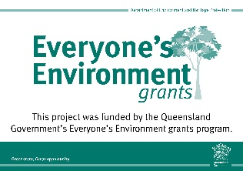
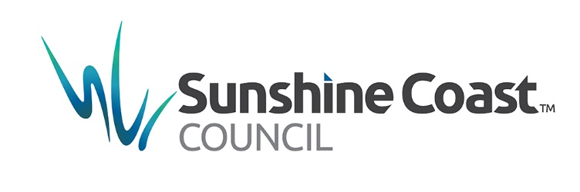
Our boat was used a little more this month, compared to last month (I realise that some of our crews are away travelling), thus reducing the amount of time our boat is on the water doing it’s garbo thing. I believe in general terms, our work is outstanding when you compare what rubbish is retrieved versus the hours logged.

