Maroochy Waterwatch Inc – River Patrol Report for November, 2016.
Number of Report Sheets : 12 compared to 10 the previous month.
Total volunteer hours : 126.75 hours compared to 103.5 hours the previous month, showing a nice increase of 23.25 volunteer hours. Great effort & noticed a new crew member of Monty’s, Mr J. Hannah assisted on three (3) days in November. Good to see.
Total non-recyclable bags collected : 31.75 bags - approx 1587 litres compared to 17.5 bags - approx 875 litres previous month. This is nearly double that of last month. Excellent effort.
Total recycled bags (if noted on report sheets) : 7.75 bags – approx 387.5 litres, compared to 6.5 bags, approx 325 litres previous month – slightly up on the previous month.
Rubbish reported collected :
One of each unless stated otherwise.-
- 4 x broken chairs & 1 x blue plastic chair.
- Large foam square box.
- BBQ flare holder
- Metal frame 1.0 x 0.5 meters size.
- Collapsed gazebo that had blown away.
- Clothes rack.
- Wooden post.
- Broken green wheelie bin.
- Several pairs of thongs.
- Large reclining arm chair.
- Wooden pallet.
- Large sheet of black plastic.
- Rack.
- 2 x car tyres.
- Car seat.
- Huge cardboard box.
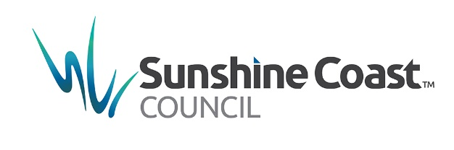
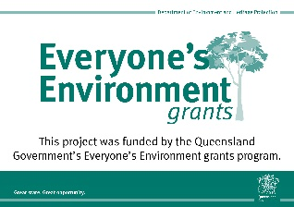
The usual reports of lots of plastic bags; plastic & glass bottles & cans

