Maroochy Waterwatch Inc – River Patrol Report for May 2015.
Number of Report Sheets : 11 compared to 9 the previous month.
Total volunteer hours : 130.25 hours vs 100.5 hours the previous month.
Total bags collected : 34 bags, approx 1,700 litres vs 25.5 bags, approx 1,275 litres previous month. Up about 34% from last month.
Total recycled bags collected : 4.5 bags, approx 225 litres........exactly the same as last month.
Flotsam & on-shore rubbish reported collected :
- 2 x crab pot floats – unmarked.
- 1 x BBQ lid.
- 1 x plastic car wheel trim
- 1 x v/heavy large glass round table top - 1,200mm diameter x 15mm thick
- 1 x large truck tyre
- 1 x tyre & rim from a 4WD.
- 1 x Port navigation marker
- Misc car parts.
- 1 x large styrene/foam piece plus several smaller styrene pieces
- 4 x plastic buckets.
- 7 x tyres
- Misc fishing Line & rope.
- Large amounts of plastic sheeting & bags..........as always.
- Large amounts of glass & plastic bottles..........as always.
- 1 x Heavy plastic parcel (contents unknown)
- Children’s toys
- 1 x Plastic barrow.
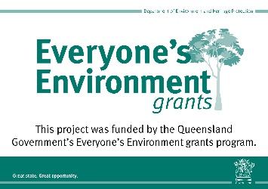
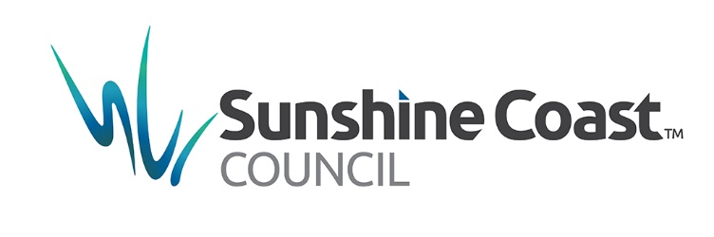
- Noted : large amounts of domestic rubbish at Coolum Ck ramp & far too much to retrieve. Council to be informed because this is a location where families launch boats in Coolum Ck.

