Maroochy Waterwatch Inc – River Patrol Report for July, 2017.

Number of Report Sheets : 16 completed - 12 last month. Nice to see boat used more this month.
Total volunteer hours : 175.25 man hours. This MUST BE A RECORD !!! Last month was 118 hours & checking back over the last 9 months to October 2016, the most hours noted was 130 hours in May 2017. Great to see guys.
Total non-recyclable bags collected : 22.5 bags – approx 1,125 litres compared to 10.5 bags – approx 525 litres previous month. This is nearly ANOTHER RECORD !!!!! The most non-recycled bags collected – going back to Oct 2016 - was 31.75 bags in Nov 2016. Well done volunteers.
Total recycled bags collected : 5.5 bags, approx 275 litres, very similar to last month at 5 bags.
Rubbish reported collected :
One of each unless stated otherwise :
- 21 x large glass bottles (calc from report sheets)
- 8 x small glass bottles (calc from report sheets)
- 18 x plastic bottles (calc from report sheets)
- 2 x Timber planks – one 700mm x 20mm square.
- Misc paper coffee cups.
- Some small pieces of rope.
- Many plastic bags.
- Many cig butts.
- 1 x 25 litre drum
- 1 x large soft plastic bucket.
- 24 x cans
- 1 x thong
- 1 x piece water pipe, 38mm diam x 1 meter long.
- Broken fishing rod & reel.
- Plastic chair.
- Lots of confectionary wrapping (again).
- Many plastic straws retrieved,
- 2 x cig packets
- Misc pieces of cardboard.
- Soccer ball.
- Toilet cistern at bus shelter beside Paynters Ck - left it there due to it’s bulk.
- 3 x Plastic chairs.
- Star picket
- Small sheet of corrugated iron.
- Steel grid.
- Skate board.
- 5m x 5m tarp.
- Tent.
- Sleeping bags (no qty shown)
- Auto fuel tank.

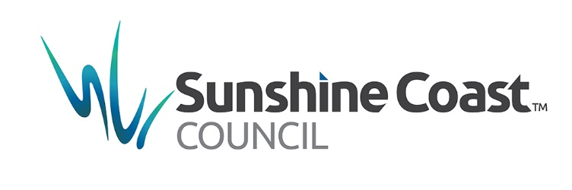
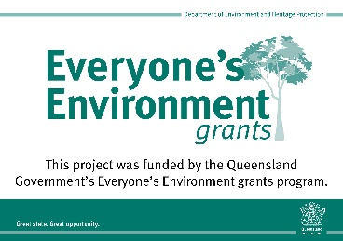
July was indeed a reasonably busy “boat-usage” month & we all should give ourselves a pat on the back. Well done to all you volunteers.

