Maroochy Waterwatch Inc – River Patrol Report for December, 2016.
Number of Report Sheets : 10 compared to 12 the previous month.

Total volunteer hours : 101.5 hours compared to 126.75 hours the previous month. This is 25.25 hours less than the previous month, however, some members away travelling, including me until March 2017, hence this & the next 3 belated reports – compiled 26/04/17.
Total non-recyclable bags collected : 24.5 bags - approx 1,225 litres compared to 31.75 bags – approx 1,587.5 litres previous month, somewhat less than previous month.
Total recycled bags collected : 3.75 bags – approx 187.5 litres, compared to 7.75 bags, approx 387.5 litres previous month. Less than half compared to last month.
Rubbish reported collected :
One of each unless stated otherwise :
- Many plastic bottles
- Aerosol cans
- Plastic bait bags
- Tyre rim
- Shopping trolley
- Metal chair
- Cane chair
- 2 x buckets
- Tractor tyre – narrow profile
- 100’s of cigarette butts (Chambers Island & Cotton Tree Park
- Car tyre
- 2 x broken chairs
- 3 x Styrene boxes
- Pram
- Paddle.
- 6 x misc objects !!
- Fire extinguisher
- Wheel trim

Lots of general plastic & glass bottles & a lot of general rubbish, not specifically listed. Hard to compare with other months but nevertheless well done “Patroller’s”
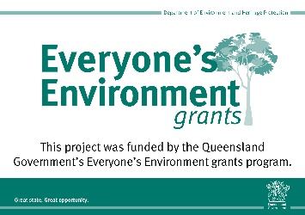
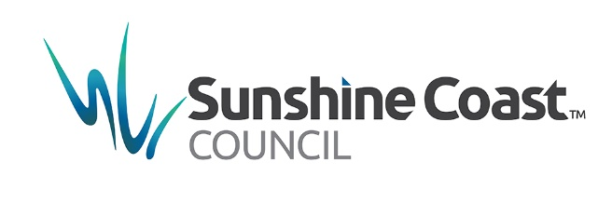
Safe boating to you all & it’s nice to be back.

