Maroochy Waterwatch Inc – River Patrol Report for August, 2017.
Number of Report Sheets : 16 completed - 16 last month too. Great to see the boat used with some hi-usage continuity.
Total volunteer hours : 163 hours. This is a little less than last month but nevertheless great to see the hours up there without any major drops in volunteer hours.
Total non-recyclable bags collected : 20.5 bags – approx 1,025 litres. This is fairly consistent with last month of 22.5 bags, approx 1,125 litres.
Total recycled bags collected : 5 bags, approx 250 litres. Again, very similar to last month at 5.5 bags, approx 275 litres.

Rubbish reported collected :
One of each unless otherwise stated:
- Glass bottles, estimate about 55, with some qty’s reported.
- Plastic bottles, estimate about 45 from report sheets where qty’s are noted.
- 2 x large sheets of plastic plus several small pieces of plastic sheet.
- Misc pieces of paper & cardboard.
- Casting net.
- Towel
- Shoe
- Cushion.
- Sun lounge
- Float ring.
- Pillow.
- 20 litre plastic fuel drum.
- 8 x thongs.
- Fishing line.
- Several small pieces of styrene.

- Length of wire.
- Red bunting.
- Bottle caps.
- Lots of food & confectionary wrappings......what’s new ???
- Cigarette butts.
- Wooden plank – 500mm long.
- 250mm piece of wood – 100mm x 100mm square.
- Misc. cans.
- Plastic planter box.
- 3 x cigarette lighters.
- 2 x plastic plant pots, medium size.
- 2 x Fishing rods.
- Plastic fishing lure
- Lot of broken glass from large beer bottles buried in mud.
- Roll of carpet.
- Beach chair.
- Coffee table.
- Few doggy pooh bags......hhhmm....hope they were empty !!!!
- 2 x Paper cups.
- Plastic bucket.
- Plastic rubbish bin.

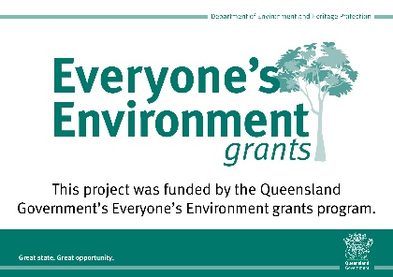
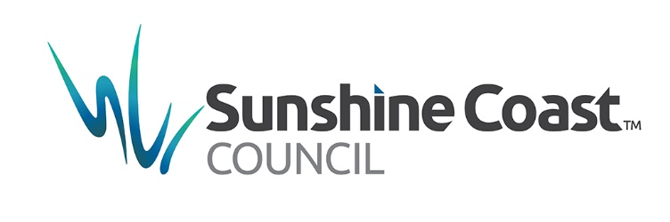
August saw the boat used about the same amount as the previous month, which is good.

